 | UNIVERSITATEA DIN CRAIOVA  FACULTATEA DE AUTOMATICĂ, CALCULATOARE ȘI ELECTRONICĂ  DEPARTAMENTUL DE CALCULATOARE ȘI TEHNOLOGIA INFORMAȚIEI | 

PROIECT DE DIPLOMĂ
Anghel Paul David

COORDONATOR ȘTIINȚIFIC
Dr. Ing. Marius Brezovan
Ing. Cătalin Sbora

Iulie 2021
CRAIOVA
UNIVERSITATEA DIN CRAIOVA
FACULTATEA DE AUTOMATICĂ, CALCULATOARE ȘI ELECTRONICĂ

DEPARTAMENTUL DE [CALCULATOARE ȘI TEHNOLOGIA INFORMAȚIEI / AUTOMATICĂ, ELECTRONICĂ ȘI MECATRONICĂ]

Racooter - trading cars website
Anghel Paul David

COORDONATOR ȘTIINȚIFIC
Dr. Ing. Marius Brezovan
Ing. Cătalin Sbora

Iulie 2021
CRAIOVA
„Învățătura este o comoară care își urmează stăpânul pretutindeni.” Proverb popular

DECLARAȚIE DE ORIGINALITATE

Subsemnatul ANGHEL PAUL DAVID, student la specializarea CALCULATOARE ENGLEZA din cadrul Facultății de Automatică, Calculatoare și Electronică a Universității din Craiova, certific prin prezenta că am luat la cunoştinţă de cele prezentate mai jos şi că îmi asum, în acest context, originalitatea proiectului meu de licenţă:
- cu titlul Racooter – trading cars website,
- coordonată de Dr. Ing. Marius Brezovan și Ing. Cătalin Sbora,
- prezentată în sesiunea Iulie 2021.
La elaborarea proiectului de licenţă, se consideră plagiat una dintre următoarele acţiuni:
- reproducerea exactă a cuvintelor unui alt autor, dintr-o altă lucrare, în limba română sau prin traducere dintr-o altă limbă, dacă se omit ghilimele şi referinţa precisă,
- redarea cu alte cuvinte, reformularea prin cuvinte proprii sau rezumarea ideilor din alte lucrări, dacă nu se indică sursa bibliografică,
- prezentarea unor date experimentale obţinute sau a unor aplicaţii realizate de alţi autori fără menţionarea corectă a acestor surse,
- însuşirea totală sau parţială a unei lucrări în care regulile de mai sus sunt respectate, dar care are alt autor.
Pentru evitarea acestor situaţii neplăcute se recomandă:
- plasarea între ghilimele a citatelor directe şi indicarea referinţei într-o listă corespunzătoare la sfărşitul lucrării,
- indicarea în text a reformulării unei idei, opinii sau teorii şi corespunzător în lista de referinţe a sursei originale de la care s-a făcut preluarea,
- precizarea sursei de la care s-au preluat date experimentale, descrieri tehnice, figuri, imagini, statistici, tabele et caetera,
- precizarea referinţelor poate fi omisă dacă se folosesc informaţii sau teorii arhicunoscute, a căror paternitate este unanim cunoscută și acceptată.
Data, Semnătura candidatului,

Description

I decided to implement a car trading platform using .NET core framework and Visual Studio community 2019 as IDE.
This is a Web application that will use C# on the backend and HTML, CSS, Bootstrap on the frontend.
There can be 3 main roles on the web application each one with individual features and responsabilities: Seller, Buyer and Admin.

App logo ideea:

„How do you call a Racoon on a scooter?”

Features

Seller:
- this is the person that is allowed to post new announcements containing the car that he/she is selling with detailed description, photos, price, phone number, location, the specifications of the car and more
- he/she can see/modify its announcements any time
- the seller can chat with the potential clients
- can add credits to its account in order to promote one or more of the announcements
- can see/Update seller information and change password/phone number/ profile picture etc.
- can add the announcement in a speciffic category
- can add a location where the car can be inspected and tested (using Google Maps API)
- see announcement number of views

Buyer: (person with an account)
- this is the persn that is allowed to see the sellers announcements and make the transactions
- can add credits to its account in order to buy a car directly within the in app credits
- can add anouncements to the favourite section
- can see/Update buyer information and change password/phone number/ profile picture etc.
- can contact the admin/moderator
- can see the phone number, location of a speciffic seller
- can message any seller on the app
- can filter the results depending on various criteria (make, model, engine HP, price, year, fuel type etc.)
- can report an announcement that is not relevant or not valid or scam
- see announcement number of views

Admin: (administrator of the website with full rights)
- after an announcement is made, it is not appearing on the website because it needs the admin aproval
- can delete announcements
- can receive the reported announcements from a buyer in order to reexaminate them
- can message a seller or buyer directly
- can add new filters to the app
- can add new categories for announcement types
- cam ban sellers from posting announcements
- can post on blog

Moderator: (a user with some admin rights)
- can accept or decline announcements
- can ban users
- can post on blog

Guest: (a person without an account)
- can make searches and apply filters
- see announcement number of views

* can’t send messages, make a buy or contact the admin

Others:
- the app can suggest some announcements to the buyer depending on his history filters, searching, and favourite announcements (using machine learning algorithms)
* to be added *

Diagrams

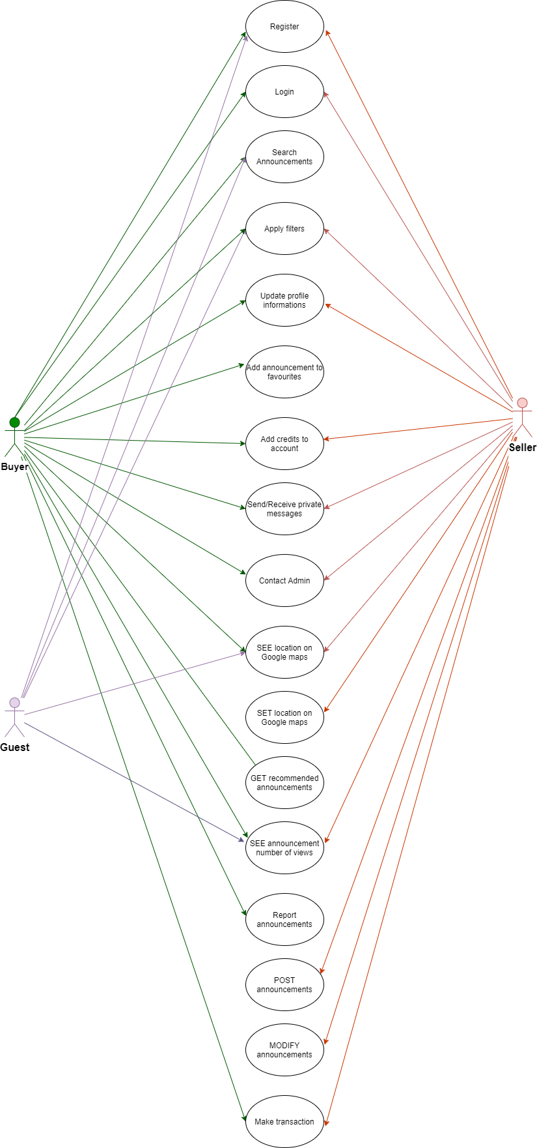
Use–case diagram Users

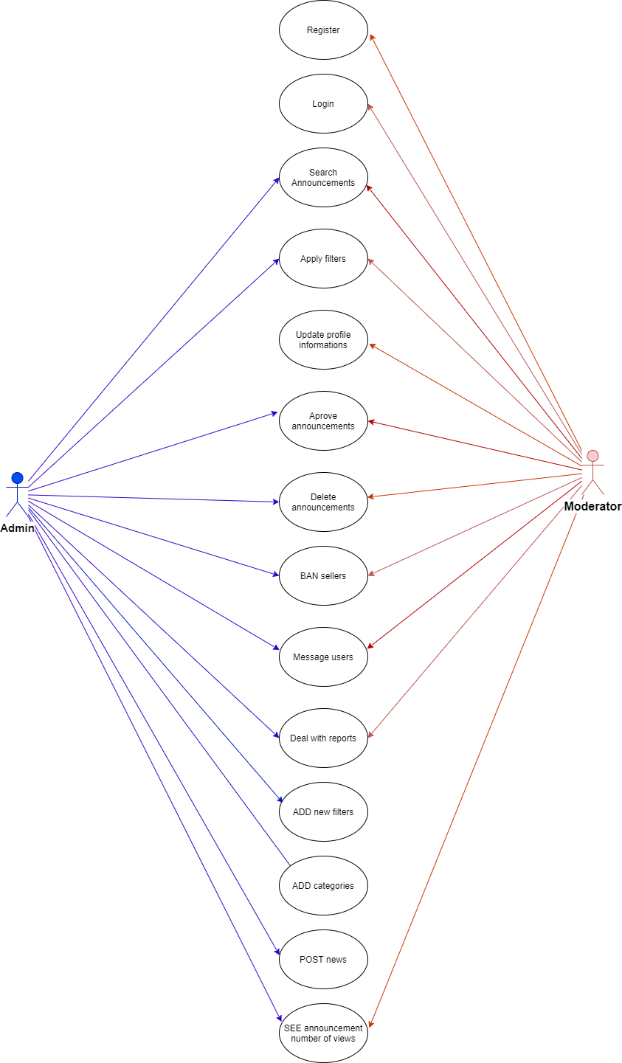
Use–case diagram Admin/Moderator:

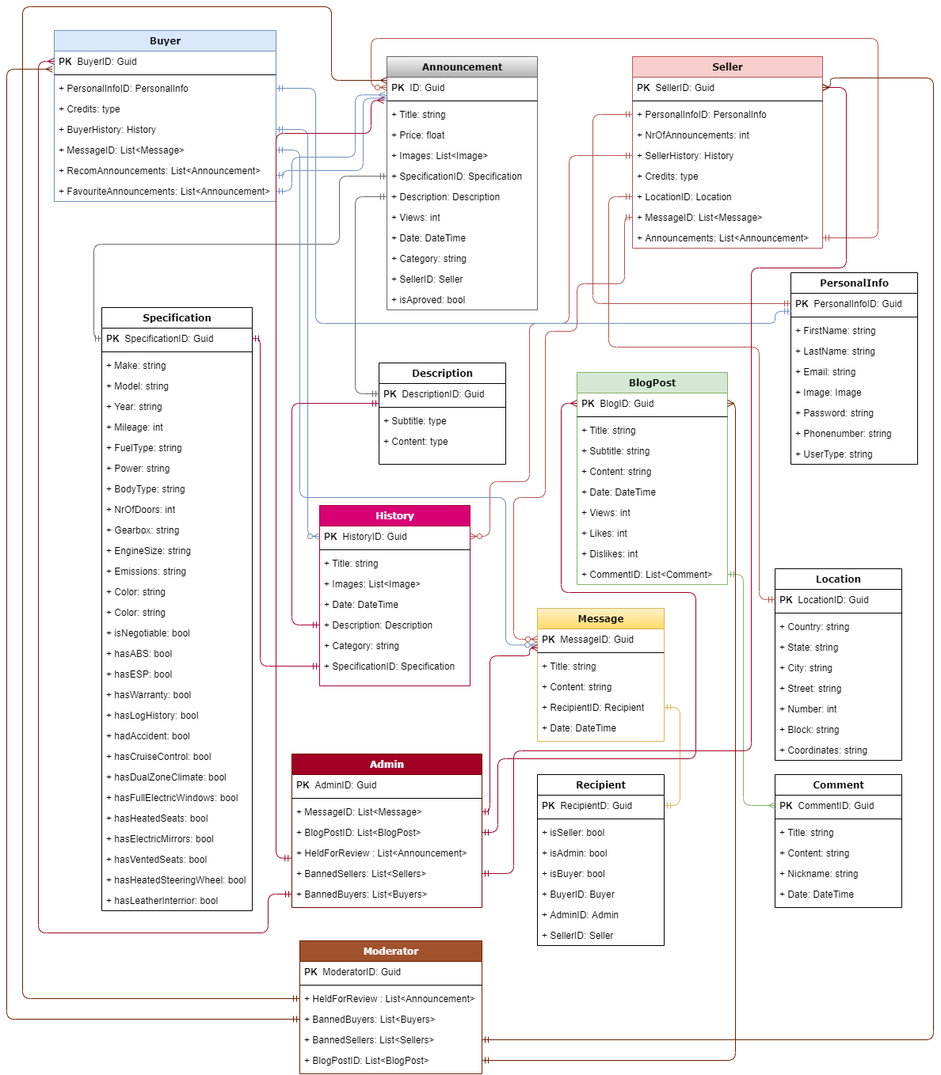
Entity Relationships Diagram

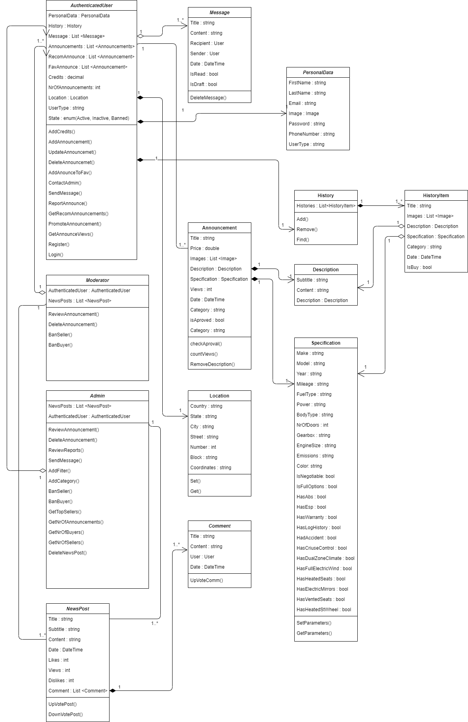
Class Diagram

Content

1) Introduction
- Purpose
- Technologies used : pe subcapitole tehnologiile(ASP.net core MVC, drawio, C#, Visual Studio, HTML, CSS, JS, Bootstrap, SSMS, Microsoft SQL Server)
- Motivation for the choice
- Chapters resume (english and romanian)

2) Online Auto Markets
- Existing Auto markets
- Functional requirements for an online auto market (main functionalities and user roles)
- Infrastructure an Architecture Requirements (arhitecture diagram, load blancing, etc )

3) Project Requirements and Specification
- Requirements (use case diagram)
- Application modelling (class diagram, data access models)
- Application Architecture (software)
- Deployment Architecture (physical components) -> Ajar

4) Implementation (code snippets, explainations, presenting with screenshots)
5) Conclusion
6) Bibliography

1. Introduction

1.1 Purpose

The main purpose of the work is to create a website that trades cars and connect buyers and sellers around the Globe in an efficient way.
The transactions are made easily in the application and the two parts can talk through messages built in the service and make the payment with credits directly in the app.
A bussines is based on buying and selling so, I tought to implement a more user friendly and easy to use application that is not depending on a speciffic currency, because in app credits are universal and can be added by each authenticated user using a wide options of their country currency.
The secondary purpose is to make the communication between sellers and buyers as easy as possible by implementing a messenger feature that alows participants to send and receive instant messages in order to make a clean and fair transaction.

1.2 Motivation for the choice

I chose to implement an online trading cars application because I am passionate about cars. I like the details and the wide range of vehicles speciffications and performance that are making them unique in their own way and are giving a special driving experience.
I think a car is an important need nowadays and everyone should have one, but new cars can be very expensive and not accessible for everybody.
So trading used cars and also almost new cars with only a few miles on board can be an answer and reach more peoples needs.
I decided to create also a messenger feature because the human communcation in any transaction is really important and I like to see peoples interacting and solving problems in the online environment.

1.3 Technologies used

Drawio

“Draw.io offers extensive drawing possibilities for process flowcharts, infographics and other visualizations on a wiki page. Descriptive graphics like process chains or decision trees can be constructed directly on a wiki page.”

ASP.net core MVC

„ASP.NET Core is a free and open-source web framework and successor to ASP.NET, developed by Microsoft. It is a modular framework that runs on both the full .NET Framework, on Windows, and the cross-platform .NET Core…
The ASP.NET MVC is a discontinued web application framework developed by Microsoft, which implements the model–view–controller (MVC) pattern. It is open-source software, apart from the ASP.NET Web Forms component which is proprietary.
ASP.NET Core has since been released, which unified ASP.NET, ASP.NET MVC, ASP.NET Web API, and ASP.NET Web Pages”

C#

„C# is a general-purpose, multi-paradigm programming language encompassing strong typing, lexically scoped, imperative, declarative, functional, generic, object-oriented (class-based), and component-oriented programming disciplines. It was developed around 2000 by Microsoft as part of its .NET initiative and later approved as an international standard by Ecma (ECMA-334) in 2002 and ISO (ISO/IEC 23270) in 2003. Mono is the name of the free and open-source project to develop a compiler and runtime for the language. C# is one of the programming languages designed for the Common Language Infrastructure (CLI).”

HTML

„Hypertext Markup Language (HTML) is the standard markup language for documents designed to be displayed in a web browser. It can be assisted by technologies such as Cascading Style Sheets (CSS) and scripting languages such as JavaScript.
HTML elements are the building blocks of HTML pages. With HTML constructs, images and other objects such as interactive forms may be embedded into the rendered page. HTML provides a means to create structured documents by denoting structural semantics for text such as headings, paragraphs, lists, links, quotes and other items. HTML elements are delineated by tags, written using angle brackets”

CSS

„Cascading Style Sheets (CSS) is a style sheet language used for describing the presentation of a document written in a markup language such as HTML. CSS is a cornerstone technology of the World Wide Web, alongside HTML and JavaScript.
CSS is designed to enable the separation of presentation and content, including layout, colors, and fonts. This separation can improve content accessibility, provide more flexibility and control in the specification of presentation characteristics, enable multiple web pages to share formatting by specifying the relevant CSS in a separate .css file which reduces complexity and repetition”

JavaScript

„JavaScript often abbreviated as JS, is a programming language that conforms to the ECMAScript specification. JavaScript is high-level, often just-in-time compiled, and multi-paradigm. It has curly-bracket syntax, dynamic typing, prototype-based object-orientation, and first-class functions.”

Bootstrap

“Bootstrap is a free and open-source CSS framework directed at responsive, mobile-first front-end web development. It contains CSS- and (optionally) JavaScript-based design templates for typography, forms, buttons, navigation, and other interface components.”

Sql Server Management Studio

“SQL Server Management Studio (SSMS) is a software application first launched with Microsoft SQL Server 2005 that is used for configuring, managing, and administering all components within Microsoft SQL Server. The tool includes both script editors and graphical tools which work with objects and features of the server.
A central feature of SSMS is the Object Explorer, which allows the user to browse, select, and act upon any of the objects within the server.”

Microsoft SQL Server

„Microsoft SQL Server is a relational database management system developed by Microsoft. As a database server, it is a software product with the primary function of storing and retrieving data as requested by other software applications which may run either on the same computer or on another computer across a network (including the Internet).”

Visual Studio

„Microsoft Visual Studio is an integrated development environment (IDE) from Microsoft. It is used to develop computer programs, as well as websites, web apps, web services and mobile apps. Visual Studio uses Microsoft software development platforms such as Windows API, Windows Forms, Windows Presentation Foundation, Windows Store and Microsoft Silverlight. It can produce both native code and managed code.
Visual Studio includes a code editor supporting IntelliSense (the code completion component) as well as code refactoring. The integrated debugger works both as a source-level debugger and a machine-level debugger.”

